**CSCI 6511 Artificial Intelligence**

**Ruocheng Shan**

**Project 1 Report – Uninformed and Informed Search**

**1. User Guide**

**1.1 Run single case test on terminal**

python main.py v.txt e.txt [start] [end]

Note:

a. v.txt and e.txt should be the absolute path of the file

b. DO NOT contain SPACE in the path

c. if not specify start and end, a random pair will be generated

Example:

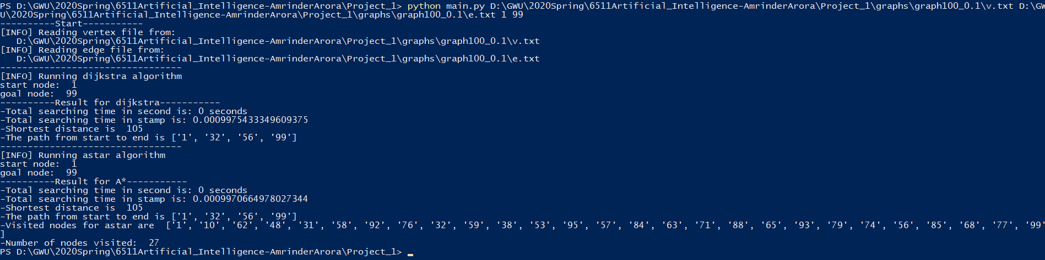

**1.2 Run all cases test on terminal**

python testall.py

Note:

a. all start and end nodes are generated randomly for each graph in testall.py

Example:

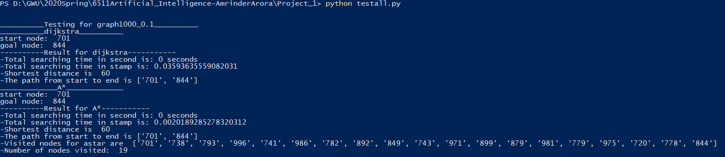

**2. Result Analysis**

**2.1 Testing Method**

· Generate random starting node and destination node pair for Dijkstra and A* search

· Note that sometimes random generated nodes are not reachable

· If two nodes are not reachable, information will be showed on log

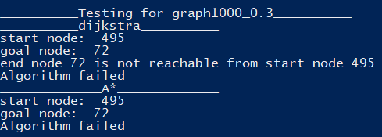

· Test for the shortest distance, path and total time cost for each algorithm

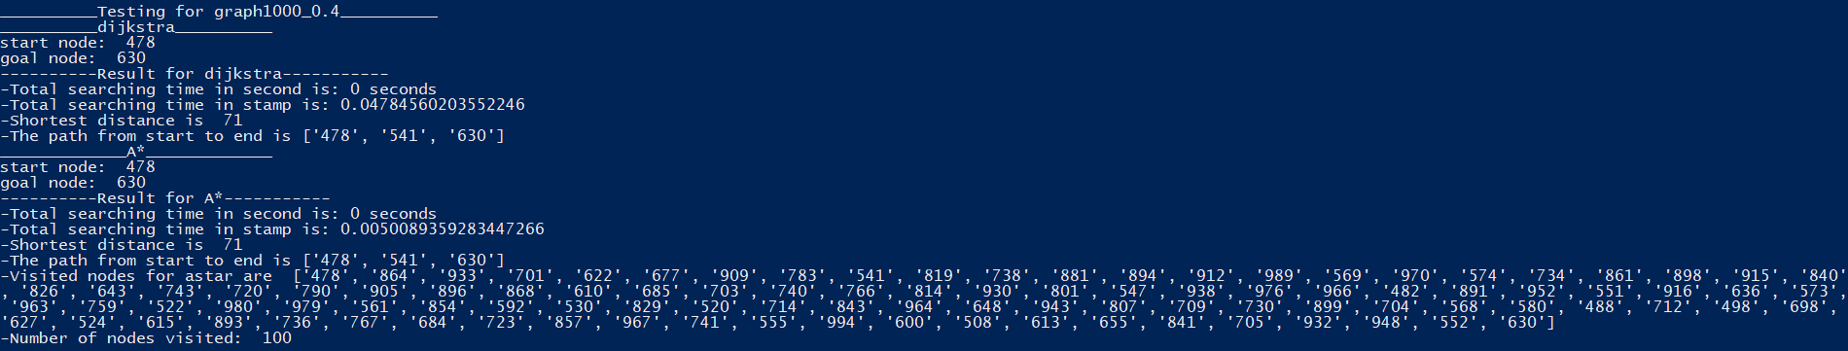

**2.2 Testing Result**

a. Total time cost of a same searching problem using Dijkstra is higher than using A*

b. All nodes are visited in Dijkstra; a relatively small number of nodes are visited in A*